Foundations of Data Science

Capstone Paper

Momentum

**Problem**

A hypothetical client approached me, wondering if he could increase his risk adjusted returns by incorporating absolute momentum into his investment strategy. While absolute momentum is academically proven to increase risk adjusted returns, he would like to know if using this approach would have affected his performance over the last several years.

**Approach**

Absolute momentum will be compared to his current model (5 ETFs held in equal proportion and rebalanced monthly).

Assets that outperform the ETF VGLT, which tracks long term government bonds, will be held for the subsequent month. The Four ETFs to be compared against VGLT are Vanguard 500 ETF (VOO), Vanguard FTSE Developed Markets ETF (VEA), Vanguard FTSE Emerging Markets ETF (VWO), and SPDR Gold Shares (GLD). VOO tracks the S&P 500 of the United States, VEA tracks developed markets not including the United States, VWO tracks emerging markets, and GLD tracks gold.

The momentum strategy is simple. First, at the end of the month, compare the performance of the four ETFs to the government bond ETF. Second, buy each one that outperformed and hold for one month.

Here is an example:



This would mean, for the subsequent month, the investor would hold 50% VGLT, 25% VEA, and 25% VOO. Lastly, this process needs to be repeated monthly.

Going back to the latest inception date of these funds, 9/9/2010, the strategy will begin on that date.

The first step in accomplishing this was to get the stock price data for all of the assets. From there, I made a data frame of the daily adjusted close prices. I then converted the daily close prices to monthly. Using the daily close prices, I calculated the monthly returns for each asset and combined them in a new data frame. I looked at the plot of adjusted close prices to visually confirm that any stock splits had been adjusted for. I then looked at a plot of the performance of each asset to visually check for outliers.

Graph 1

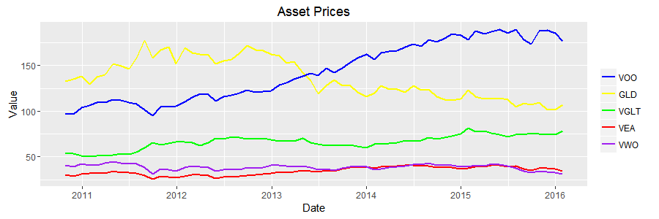

Graph 1 shows the change in stock prices over time for the duration of the strategy. Because there are no drastic increases or decreases in the prices of any of the assets, it’s clear that there are no stock splits that have not been adjusted for.

Graph 2

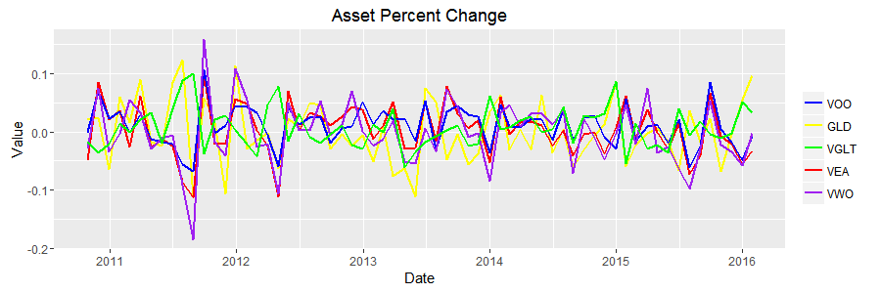

Graph 2 shows monthly return calculated for each of the assets. There are no extreme outliers that would indicate any issues with the price data or miscalculation of the monthly returns.

The second step was to code the trading rules. Subtracting the monthly return of the ETFs from VGLT gave a data frame of positive and negative values. I then changed all the positive values to buys because a positive value would indicate that the return for that asset was greater than VGLT. All negatives were coded as CASH which represents holding VGLT. These decisions were then combined into a data frame. The first month was removed because one of the funds did not exist before that date, SO there was no performance that could generate a decision to buy for the following month. Likewise, the last month was removed because decisions for the following month can’t be made until this month ends.

The third step was replacing Buys and Cash with the corresponding asset returns. To do this, I had to change to numeric values before I could replace them. I then checked to make sure all buys = 1. I could have directly set buys to numeric values, but it was easier to check with the non-numeric assignment.

The fourth step was to look at performance. I made a data frame of the monthly returns for the strategy and then took the average of the monthly returns to get the strategy return for each month. I then calculated the hypothetical growth of 10,000 dollars for the strategy. I repeated these steps for the benchmark. With the starting and ending values, I could calculate the compound annual growth rate for both the strategy and benchmark, the standard deviation, and the return / standard deviation ratio which I am using to measure risk adjusted return.

The final step was to merge some data frames and columns for graphing purposes and to standardize asset prices by making the hypothetical growth of 10,000 dollars. I graphed the hypothetical growth of 10,000 dollars for the strategy and the benchmark, the performance of the strategy vs the assets, and the performance of the benchmark vs the assets.

Graph 3

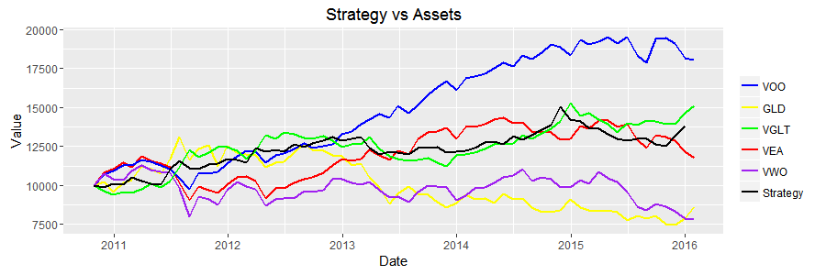

Graph 3 shows they hypothetical growth of $10,000 for each of the assets and the momentum strategy. Where the assets trend downwards, there is a stronger relationship between the strategy and VGLT, as would be expected given the trading rule. Because the strategy tracks VGLT so closely, it’s clear that the portfolio would benefit from the addition of assets with lower correlation.

Graph 4

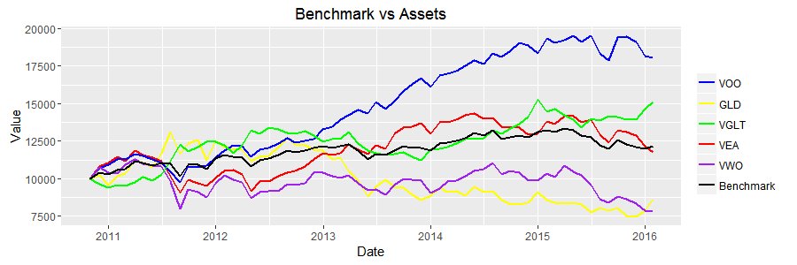

Graph 4 shows they hypothetical growth of $10,000 for each of the assets and the benchmark. The benchmark is an average of the performance of all of the assets because it holds each of them in equal proportion.

Graph 5

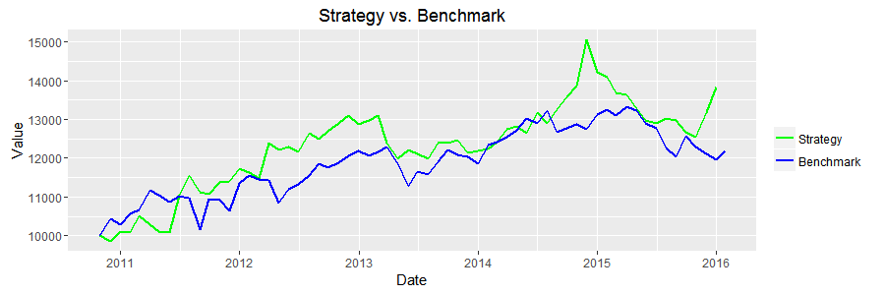

Graph 5 shows they hypothetical growth of $10,000 for both the strategy and the benchmark. They appear highly correlated because VGLT, which the strategy was heavily weighted in, had average performance. Had VGLT not fallen so close to the average returns of the other assets the difference between the strategy and the benchmark would be much more significant. Over all the strategy outperforms the benchmark in terms of return.

**Findings**

Table 1

Table 1 shows that the strategy beats the benchmark in terms of compound annual growth rate, and return/volatility. The benchmark did show lower volatility than the strategy but the difference is minimal.

|  |  |  |
| --- | --- | --- |
|  | **Benchmark** | **Strategy** |
| CAGR | 3.49% | 6.37% |
| Standard dev | .028 | .030 |
| Return/SD | .12 | .19 |

The difference between the benchmark was not as drastic as expected. Flat performance by two of the four assets, VEA and VWO, was a major factor in limiting the effect of momentum. Despite the limited effect, the strategy did outperform the benchmark 6.37% vs 3.49% annually. Unfortunately, the strategy also increased the volatility of returns measured by the standard deviation, .030 vs .032. Looking at the ratio of compound annual growth rate to standard deviation, the strategy did improve risk adjusted returns. Because risk adjust returns were increased, despite flat performance by two of the 5 assets, I am recommending that the momentum strategy be incorporated into the client’s model. I would strongly recommend the client use a greater number of ETFs to find some with lower correlation so the effect of momentum can be increased. There were periods where only VGLT was held because the other assets had underperformed the prior month. This is a clear signal that more assets need to be included and might be why the momentum strategy had higher volatility. I would also recommend further back testing to see if other types of momentum, like relative strength, could improve their performance more significantly. Overall I would recommend using the strategy and strongly recommend further testing to find more significant improvements.